**Title: Web Crawler Real Estate** 

**Analysis Goal**

Buyers able to analyse and identify of the trending cost of similar properties within the same area of a community, as well as other characteristics such as features of the property.

**Analysis Data**

This data was scrape or crawl from a Hometrovit page where focus only Cheras city or zone or address with maximum and minimum price, 100k to 500k.

**CSV FILE : **

**SAS DATASET : **

**Import csv to sas dataset**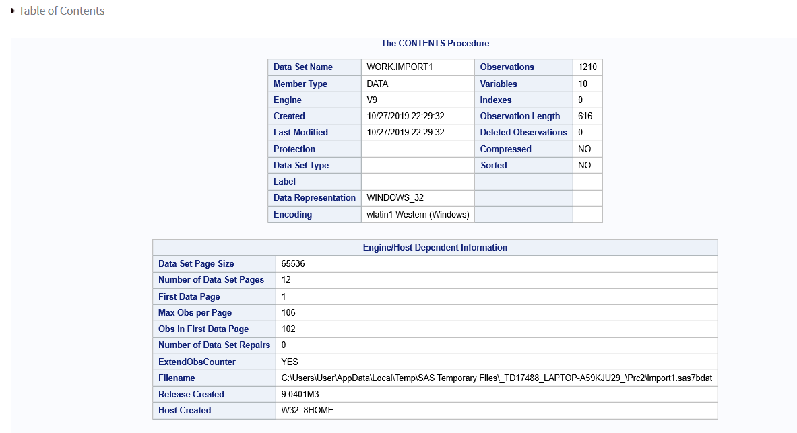

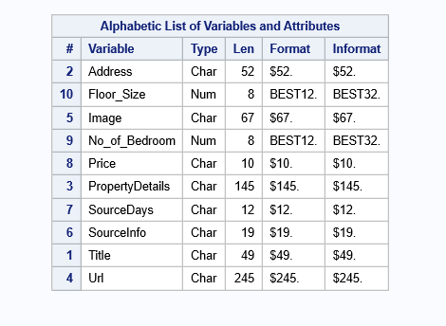

**Metadata Table**

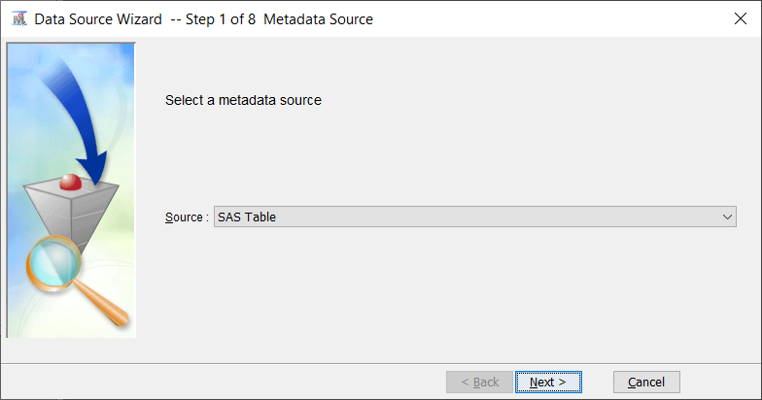

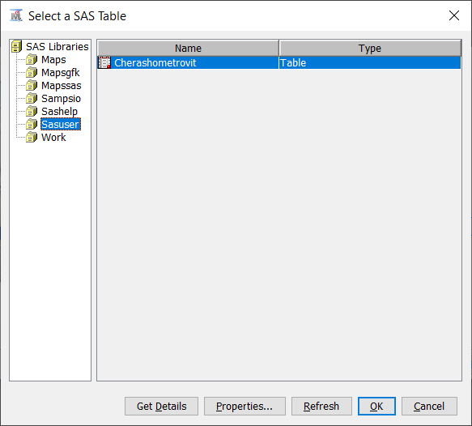

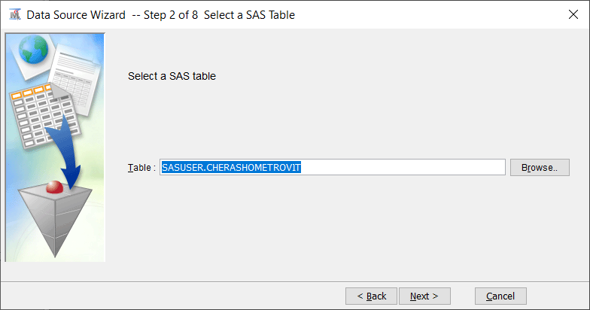

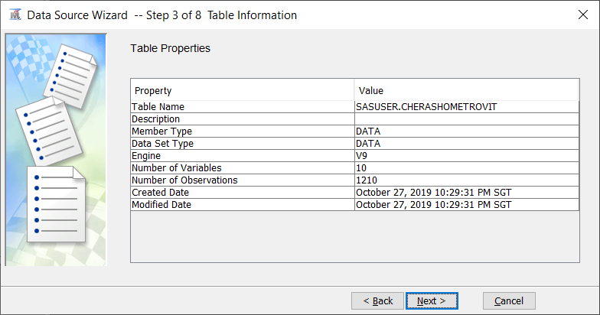

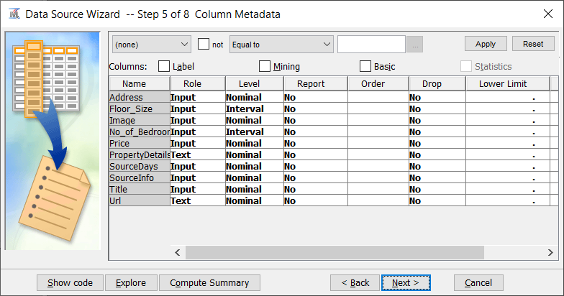

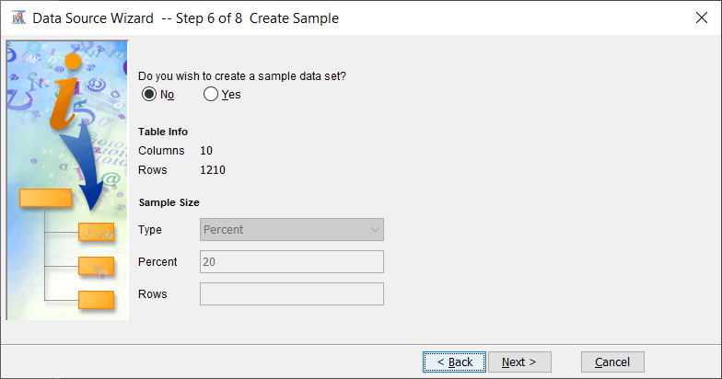

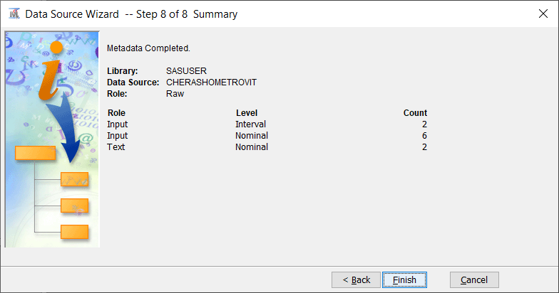

**Explore Data**

